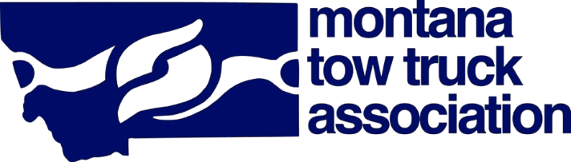
Saturday, September 20, 2025
Friday, September 19, 2025
Sunday, September 21, 2025
8:00-9:00 Breakfast
9:00-12:00 Flagger School Certification-Steve Jenkins instructor
12:00-2:00 Lunch
12:00-2:00 Ladies Luncheon served by the board of directors. (cocktail attire)
2:00-3:30 Organizational Leadership-Speaker Scott Rosberg
3:30-4:30 Round Table Discussion
President Scott Wolff and Sargeant Tammy Perkins answer your questions
5:00 Meet and Greet
Family Feud

8:00 Breakfast
9:00 Annual Meeting

7:00-8:00 Breakfast
9:00-1:30 Tow Truck Show and Shine
10:00-12:00 Car Show! Bring your hotrod, classic car or classic semi-truck and show it off.
1:30 Show and Shine Ends, Towels Down-Judging begins
12:00-1:30 Lunch with Vendors! Tailgate party with the vendors. (Wear your favorite jersey)
Poker run with vendors and bar, five cards, best hand wins
1:30-3:00 Fun and Games
5:00 Cocktail hour
6:00 Banquet, Live and Silent Auction, Women of the Industry Awards (semi formal-formal)

Subject to change

2025 Tow Convention

Schedule of Events

